**SSR 21-22 _ Team:044:**

***This is the document containing links and photos of feedback forms, Quizes statistics, webinar recorded video, our total workbook folder. ***

1. [SSR-44 Quiz and feedback Statistics](https://amritauniv-my.sharepoint.com/:f:/g/personal/bachinaabhinay_am_students_amrita_edu/EhBplH7v2-NMp-llJwUnYhoBb567aBDYg0Asz2klRKVpUQ?e=xRXvZB) ---- Click to Access
2. [Meeting Recordings](https://amritauniv-my.sharepoint.com/:f:/g/personal/bachinaabhinay_am_students_amrita_edu/EkoI718p-mRNjhV5tk8Bv0YBq68oEwLwkx2VLaHZU-ZT2w?e=2RtSin) ---- Click to Access
3. [SSR Team-44 REPORT.pdf](https://amritauniv-my.sharepoint.com/:b:/g/personal/bachinaabhinay_am_students_amrita_edu/EasUKq-oVy1KuG9iC83ZFdUBgXyeqyo0IzbC5ltiqaqoLw?e=x0lXrQ) ---- Click to see Project report
4. [SSR-44](https://amritauniv-my.sharepoint.com/:f:/g/personal/bachinaabhinay_am_students_amrita_edu/Enn0c1FTkdNNvz5tG4b5PjgBpBnWRbYNgTIVa20-yaQOtw?e=tmaZNK) ---- Click to Access all Our team work sheet.

**Feedback forms:**

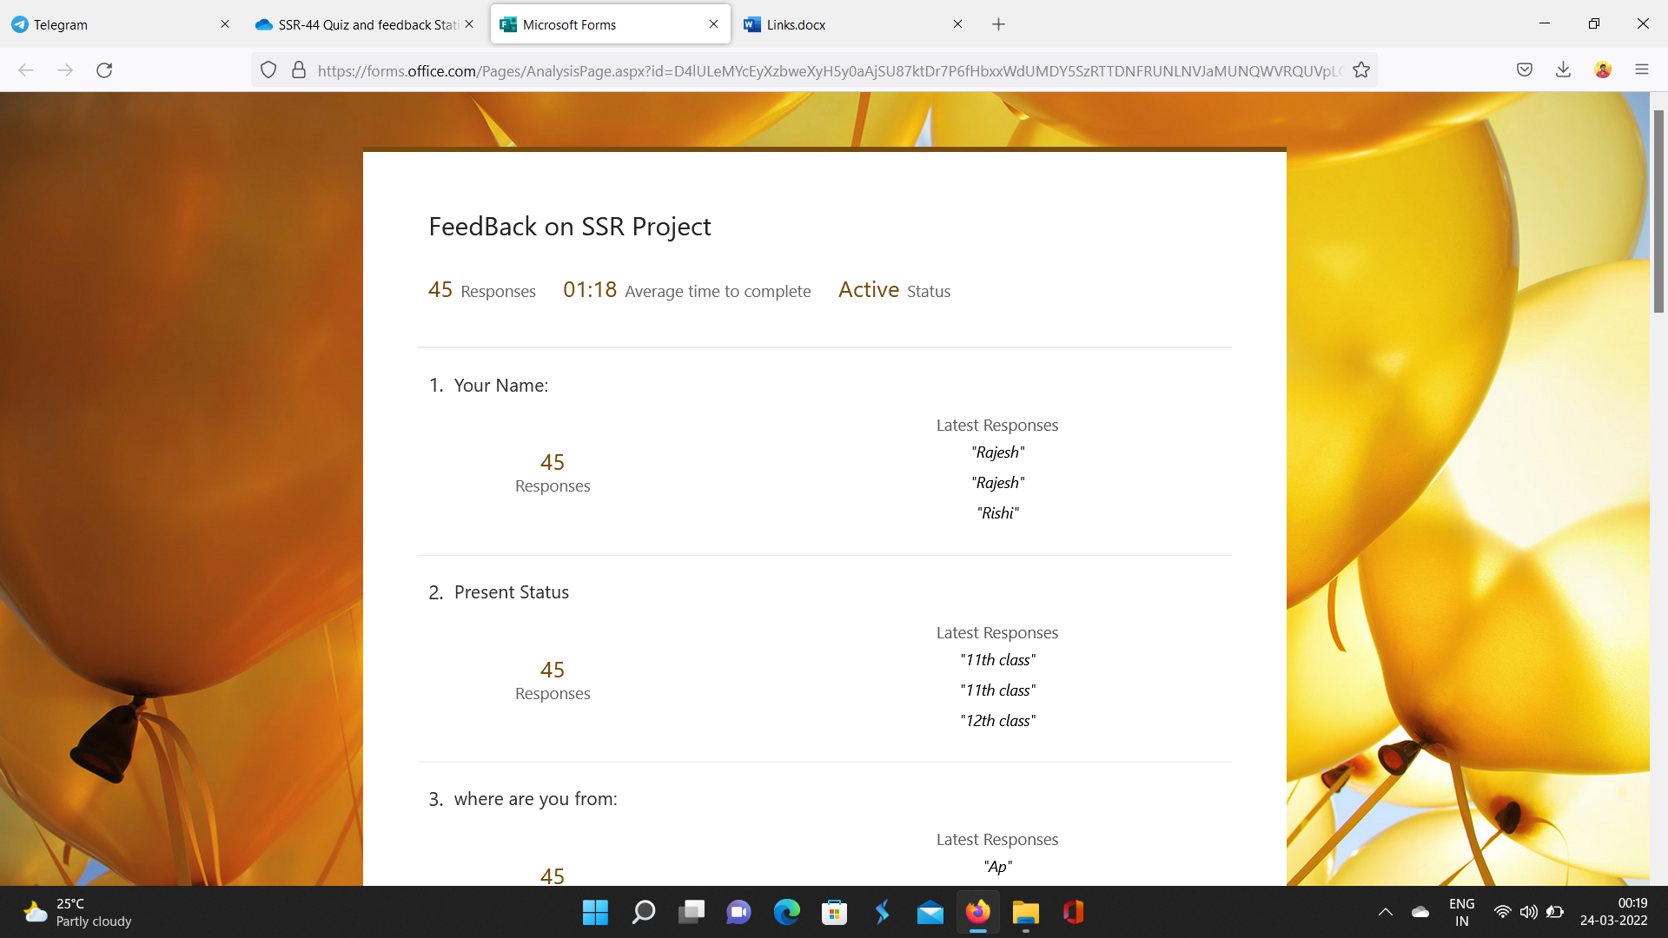

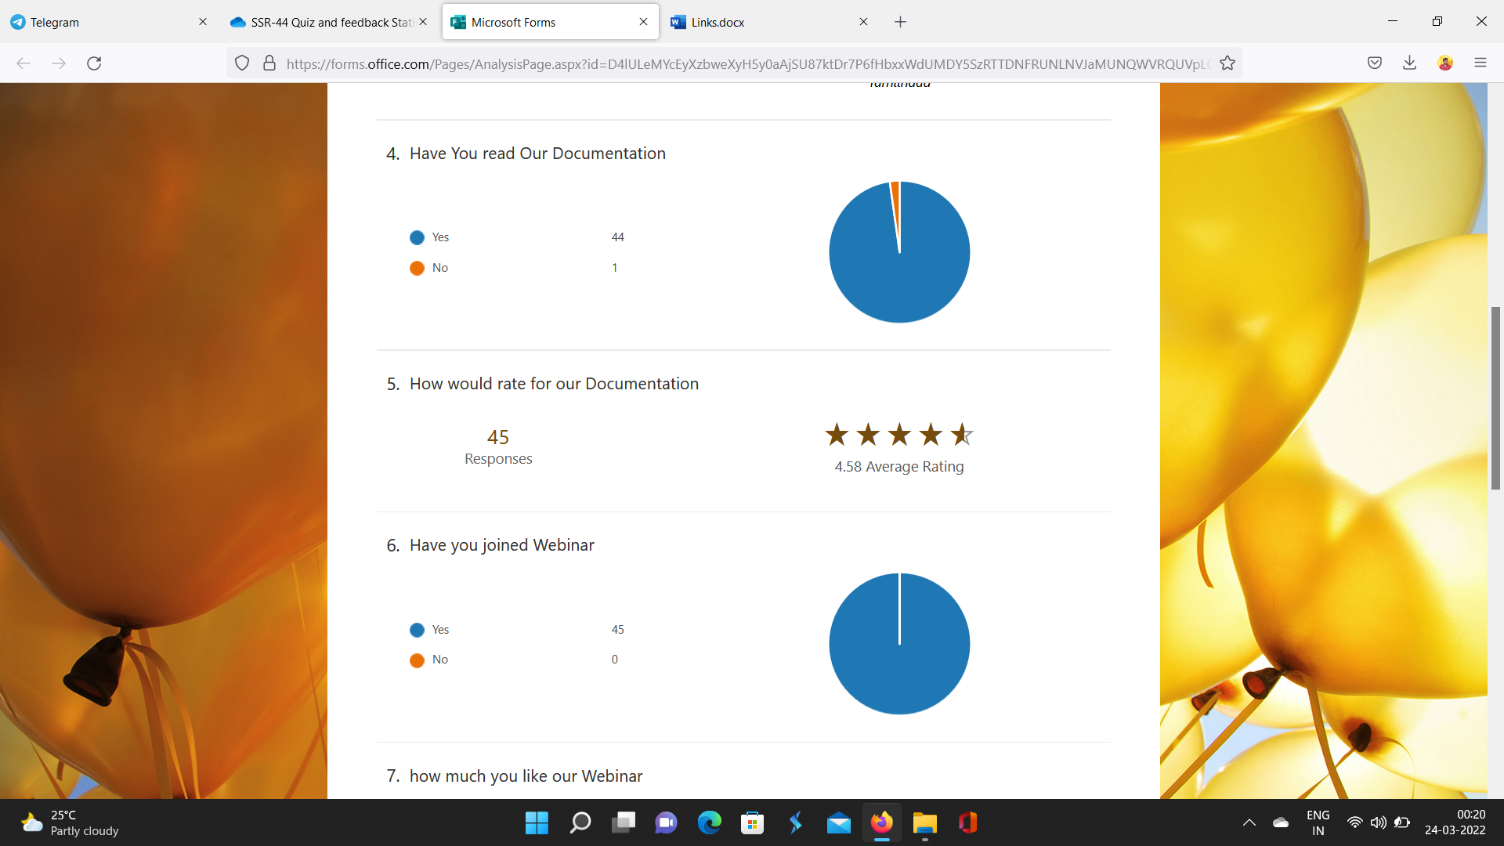

**Quiz-1 Responses:**

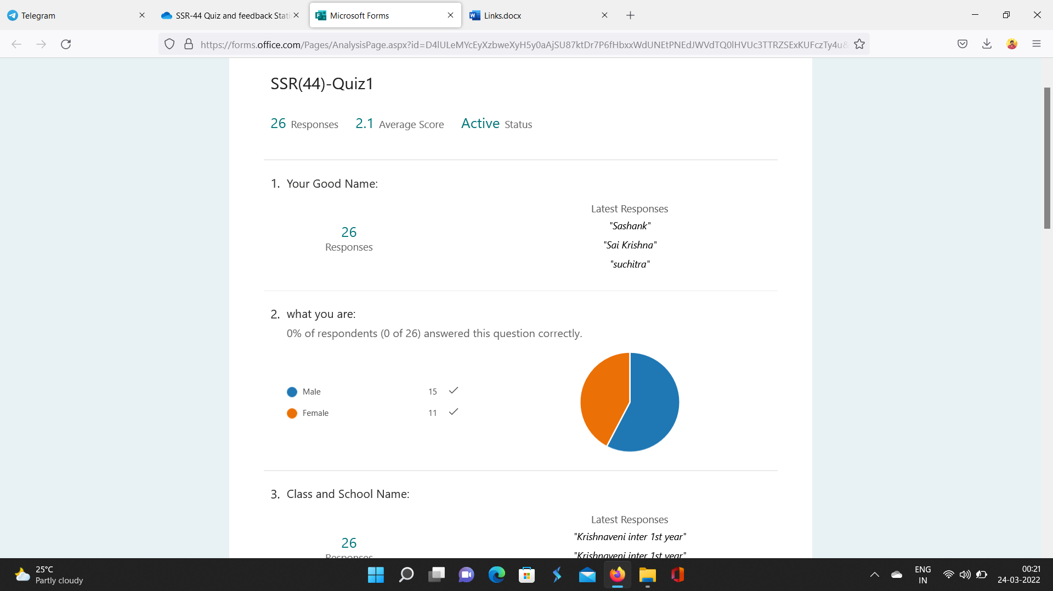

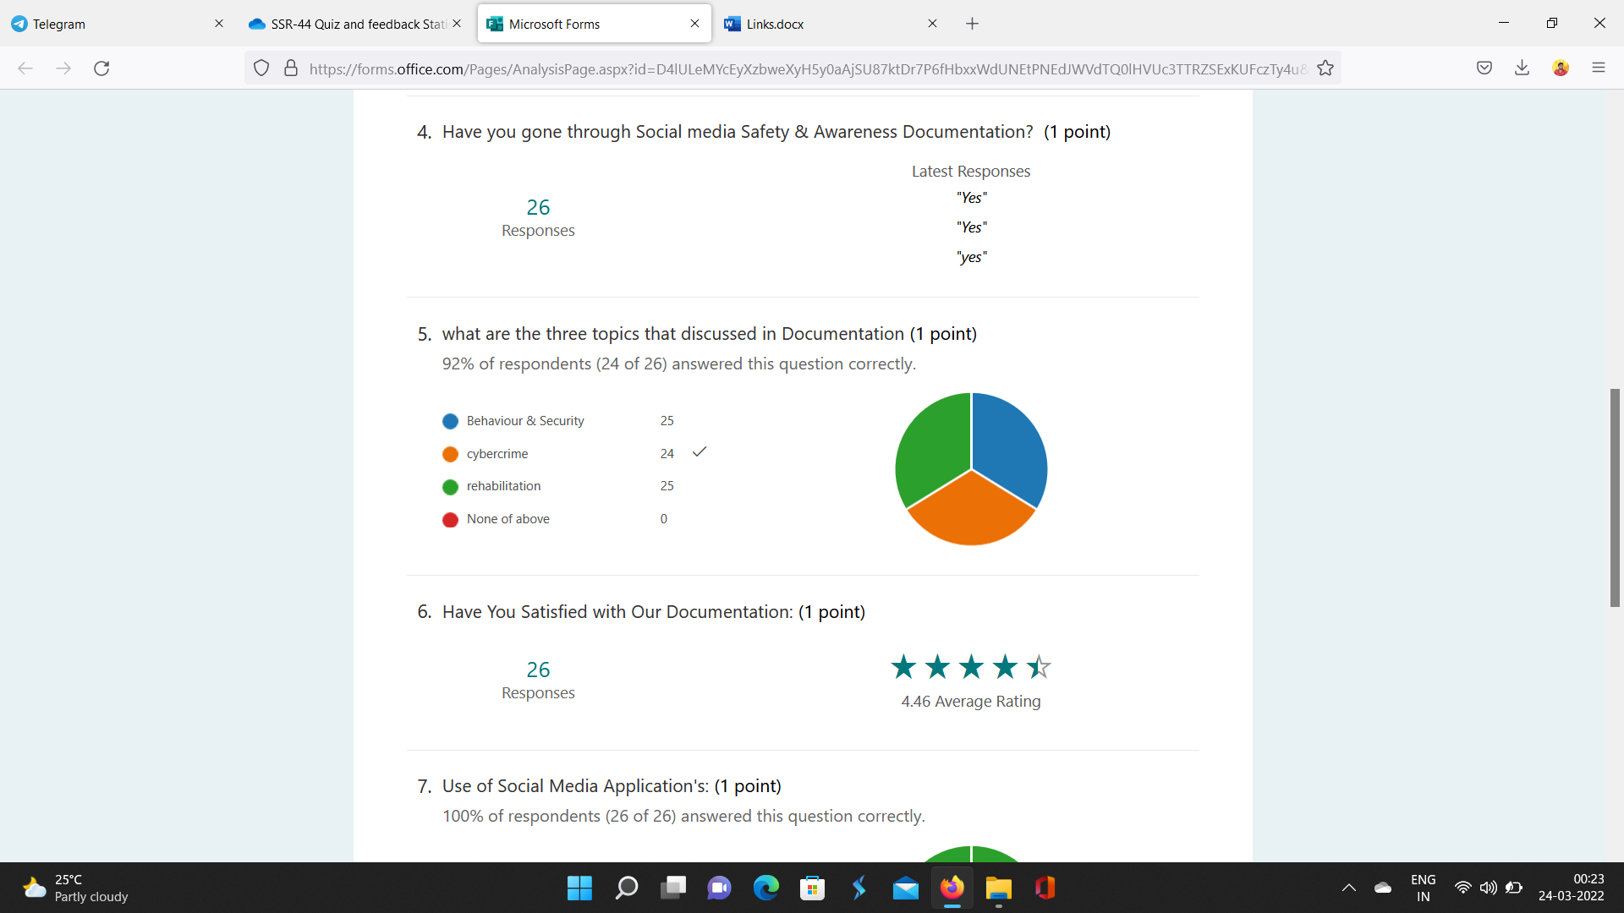

**Quiz-2 Responses:**

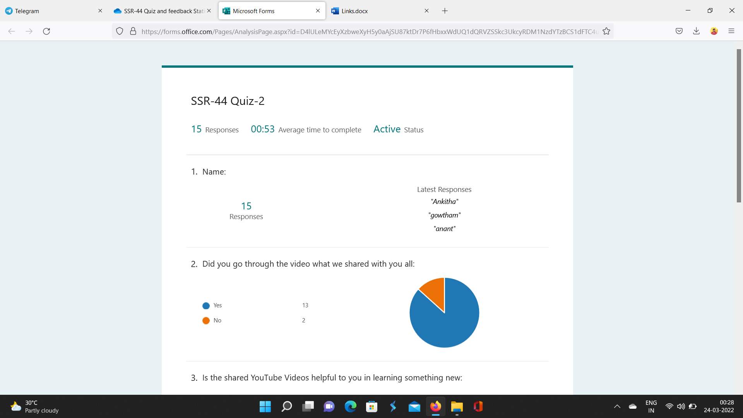

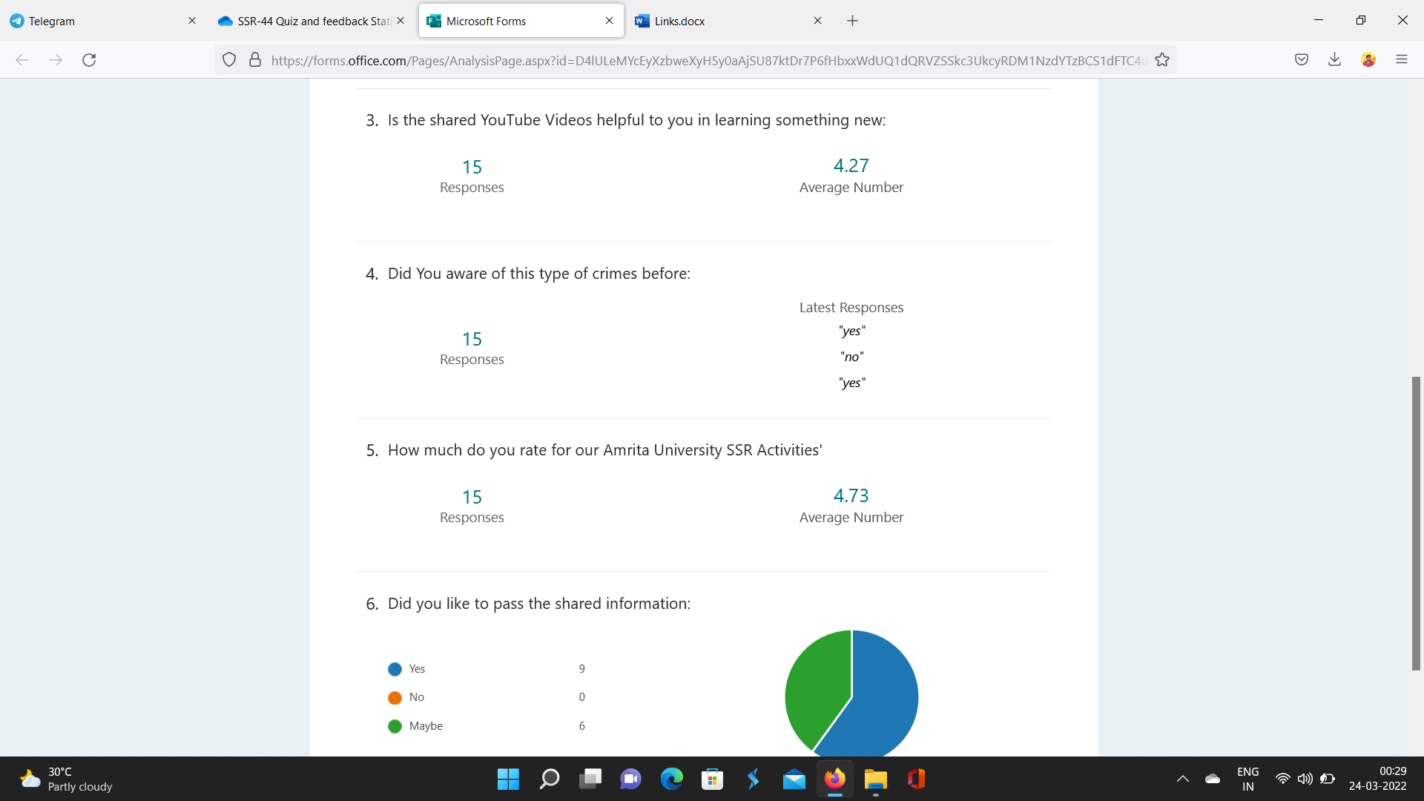

Activity-0 Project approval:

Activity-1 Document Distribution:

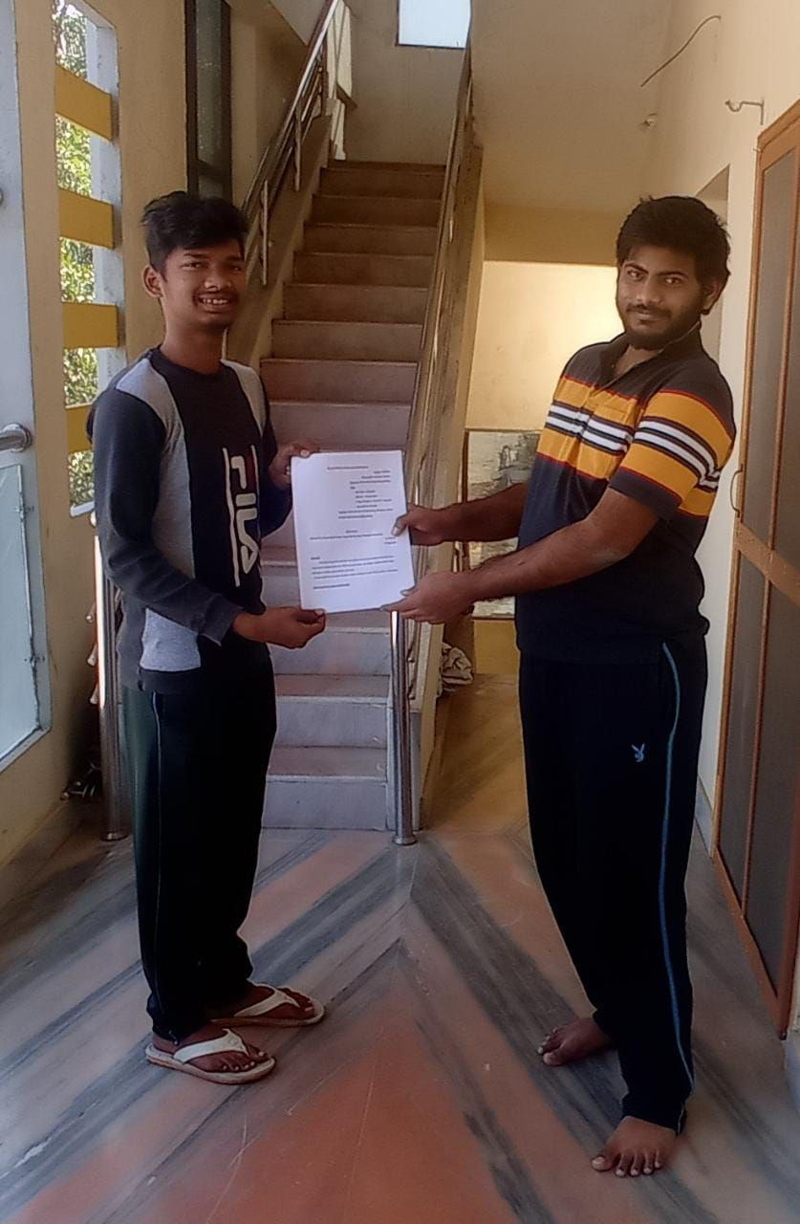 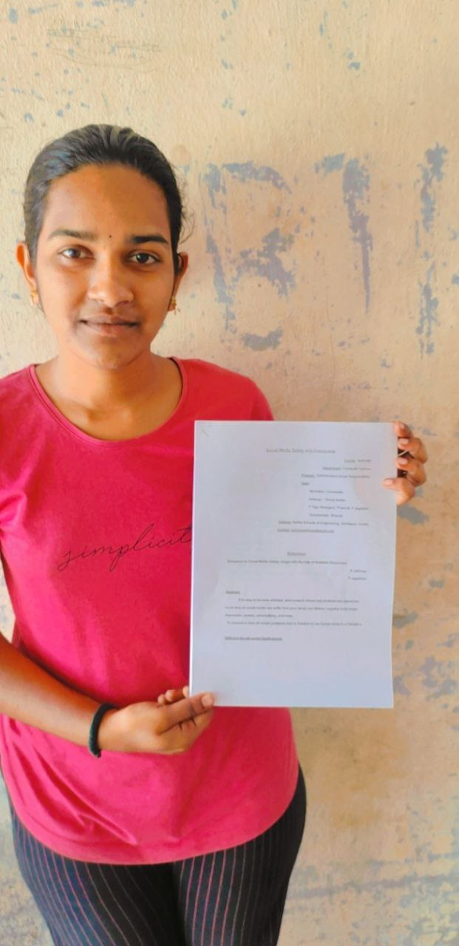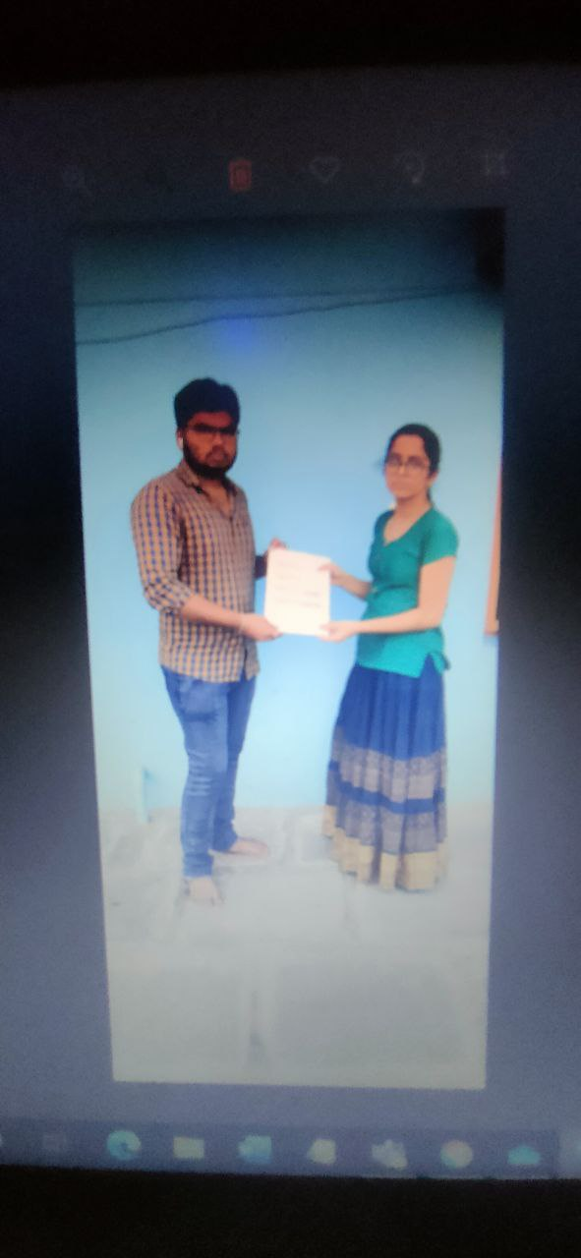

Activity-2 promotions for webinar:

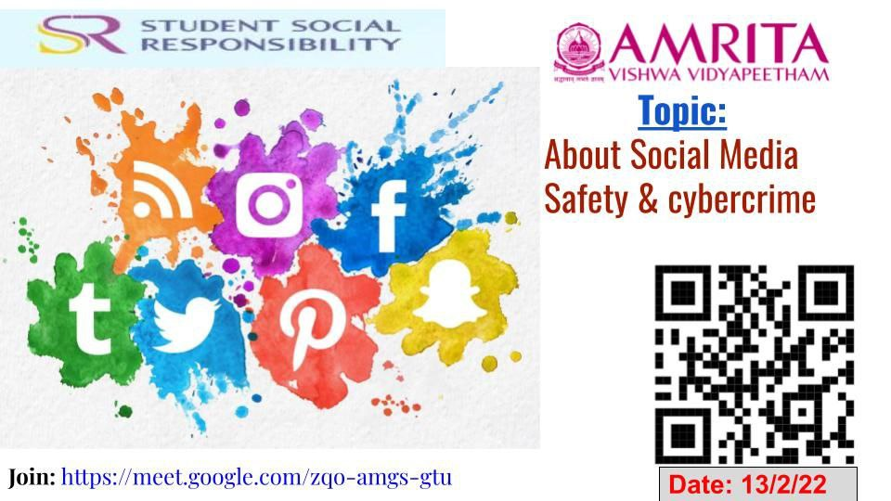

Activity-3 Webinar on Google meet:

